Study at Anhui Xinhua University
1. Introduction of the University
Anhui Xinhua University, invested to set up by Anhui Xinhua Group in 2000, is the first private university in Anhui Province authorized by the Ministry of Education to offer Bachelor’s degree. The comprehensive university is situated in Hefei, the capital of Anhui Province, which is well-known for advanced science, technology and education. The university, located beside of the beautiful Dashu Mountain national forest park, covers an area of 10,000,000 square meters with 500,000 square meters of building area. The university, with more than 20,000 students, is the largest and best private university in Anhui Province.
Now, the university has 72 undergraduate and graduated specialities, covering majors of technology, engineering, science, economics, management, literature and so on. The university has a nice living and studying environment. With beautiful campus, tidy and bright classrooms, clean and warm dormitories, resourceful library, and practice and training bases, the university is an ideal place for studying and living.
To create great campus atmosphere, the university organizes various activities, so that students here can enjoy and live a colorful campus life.
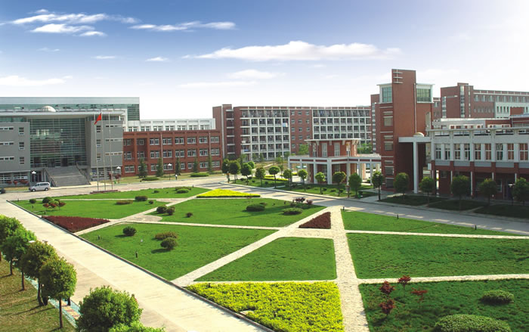
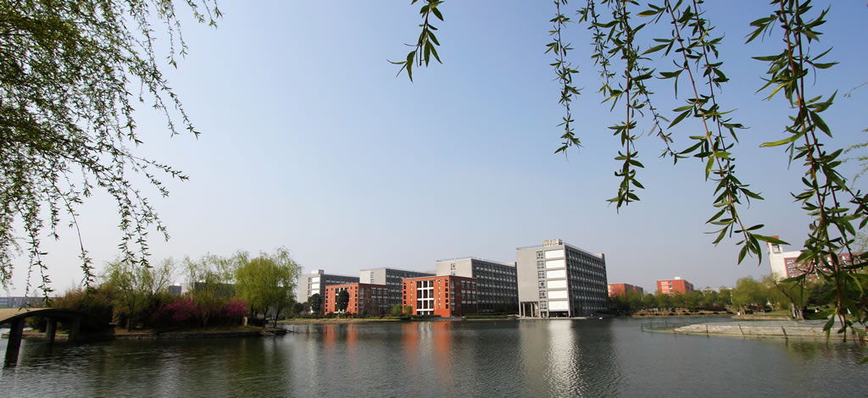
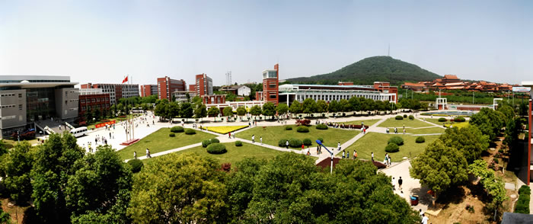

2. Program Benefits of Anhui Xinhua University
Professional courses in Chinese and English
According to the curriculum education and needs of international students, the professional courses are mainly taught in Chinese and supplemented by English.

Zero language foundation enrollment
There is no language level requirement for enrollment, and experienced professional Chinese teachers conduct language training.

Low cost and generous scholarship
The cost of studying abroad is far lower than that of Europe and the United States. According to the scores, students can obtain scholarships of up to 10000 RMB yuan each year, which greatly reduces the pressure of studying abroad.
Full service from school to employment
Anhui Xinhua University has set up the service center for international students to provide full-service for foreign students in living and studying. Before graduation, the university will provide students with internship chances.
Beautiful campus environment, comfortable living space
Anhui Xinhua University is located at the foot of the beautiful Dashu Mountain national forest park, with better environment and fresh air. The dormitory for foreign students is clean and tidy. All rooms are equipped with air-conditioning, separate toilets, hot water, laundry facilities, and a kitchen for international students.
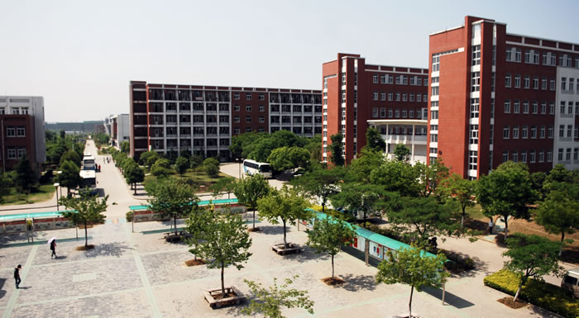
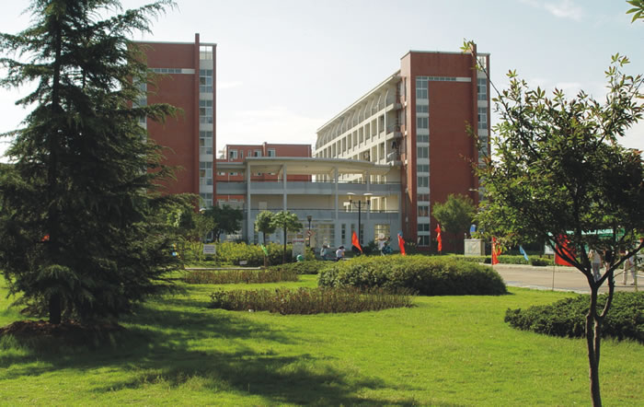

3. Specialties recruited
International Economics and Trade;
Civil Engineering;
Computer Science and Technology
Electric Engineering and Automatic

4. Targets recruited
Recruiting outstanding senior high school graduates

5. Application conditions
(1) Senior high school graduates or students with equivalent degree;
(2) With an average score of C or comprehensive score of more than 75, major performance shall be assessed by major teachers.
(3) No criminal record
(4) Physical examination certificate
(5) The family has good economic conditions and can afford all the expenses for studying abroad
6. Tuition
4 years of major study, 8 semesters in total (not include Chinese language study), 20000 yuan per year
Accommodation: 2000 yuan / year, insurance: 800 yuan / person / year
During the period of studying in school, international students can get high Scholarship (10000yuan / year) according to their achievements.
In order to encourage overseas students to study in our school, the first year's applicants are all entitled to 10000 yuan scholarship.
7. Schooling and certificate
Students who apply for major study must pass HSK level 4, otherwise they cannot enter the major course. Those who fail to pass the first year of Chinese study can continue to study Chinese or apply for dropping out.
If you have completed the course and passed the examination, you will obtain the academic degree certificate issued by Anhui Xinhua University.

8. Application time
Admission in September in autumn, application time up to the end of June of the year

